BÁO CÁO THỰC HÀNH LAB 5  
LẬP TRÌNH HƯỚNG ĐỐI TƯỢNG

Mục lục

1. Swing components 4

1.1. AWTAccumulator 4

1.2. SwingAccumulator 4

2. Organizing Swing components with Layout Managers 4

2.1. Create class NumberGrid 4

2.2. Adding buttons 5

2.3. Complete inner class ButtonListener 5

2.3. Demo 6

3. Create a graphical user interface for AIMS with Swing 6

3.1. View Store Screen 6

3.1.1. Create the StoreScreen class 6

3.1.2. The NORTH component 7

3.1.3. The CENTER component 8

3.1.4. The MediaStore class 8

3.1.5. Putting it all together 9

3.2. Adding more user interaction 9

4. JavaFX API 12

4.1. Create the FXML file 12

Step 1. Configuring the BorderPane – the root element of the scene 12

4.3. Create the application 17

4.4. Practice exercise 18

5. Setting up the View Cart Screen with ScreenBuilder 20

6. Integrating JavaFX into Swing application – The JFXPanel class 25

7. View the items in cart – JavaFX’s data-driven UI 26

8. Updating buttons based on selected item in TableView – ChangeListener 28

9. Deleting a media 29

10. Filter items in cart – FilteredList 29

11. Complete the Aims GUI application 30

12. Use case Diagram 36

13. Class Diagram 37

Mục lục ảnh

Figure 1: Source code of AWTAccumulato (1) 4

Figure 2: Source code of AWTAccumulato (2) 4

Figure 3: AWT Accumulator 4

Figure 4: Source code of SwingAccumulator (1) 4

Figure 5: Source code of SwingAccumulator (2) 4

Figure 6: SwingAccumulator 4

Figure 7: NumberGrid source code(1) 4

Figure 8: NumberGrid source code(2) 5

Figure 9: NumberGrid source code(3) 5

Figure 10: Number Gird 6

Figure 11: Declaration of StoreScreen class 6

Figure 12: createNorth() source code 7

Figure 13: createMenuBar() source code 7

Figure 14: createHeader() source code 7

Figure 15: createCenter() source code 8

Figure 16: MediaStore source code 8

Figure 17: StoreScreen constructor source code 9

Figure 18: MediaStore lass source code(1) 9

Figure 19: MediaStore lass source code(2) 10

Figure 20: MediaStore lass source code(3) 11

Figure 21: View Store Screen 11

Figure 22: Configuring the BorderPane 12

Figure 23: Configuring the VBox 12

Figure 24: Configuring the Pane 13

Figure 25: Configuring the Button 13

Figure 26: Preview in Window 14

Figure 27 : Source code of Painter.fxml (2) 15

Figure 28: Source code of Painter.fxml (3) 15

Figure 29: Source code of PainterController Class 16

Figure 30: Painter source code 17

Figure 31: Source code of Painter.fxml update (1) 18

Figure 32: Source code of Painter.fxml update (2) 18

Figure 33: Source code of Painter.fxml update (3) 19

Figure 34: Painter with Eraser 19

Figure 35: Source code of Cart.fxml (1) 20

Figure 36: Source code of Cart.fxml (2) 21

Figure 37: Source code of Cart.fxml (3) 22

Figure 38: Source code of Cart.fxml (4) 23

Figure 39: Source code of Cart.fxml (5) 23

Figure 40: View Cart Screen 24

Figure 41: Source code for CartScreen(1) 25

Figure 42: Source code for CartScreen(2) 26

Figure 43: Source code for CartScreenController (1) 26

Figure 44: Source code for CartScreenController (3) 27

Figure 45: Modified initialize() method 28

Figure 46: Source code of updateButtonBar() 28

Figure 47: Handle remove media 29

Figure 48: Creat corresponding attributes in the controller 29

Figure 49: Adding ChangListener for tfFilter in initialize() 29

Figure 50: Source code of showFilteredMedia() 30

Figure 51: UseCase Diagram Customer 36

Figure 52: UseCase Diagram Store manager 37

Figure 53: Class Diagram update 38

# 1. Swing components

## 1.1. AWTAccumulator

Figure : Source code of AWTAccumulato (1)

Figure : Source code of AWTAccumulato (2)

Figure : AWT Accumulator

## 1.2. SwingAccumulator

Figure : Source code of SwingAccumulator (1)

Figure : Source code of SwingAccumulator (2)

Figure : SwingAccumulator

# 2. Organizing Swing components with Layout Managers

## 2.1. Create class NumberGrid

Figure : NumberGrid source code(1)

## 2.2. Adding buttons

Figure : NumberGrid source code(2)

## 2.3. Complete inner class ButtonListener

Figure : NumberGrid source code(3)

## 2.3. Demo

Figure : Number Gird

# 3. Create a graphical user interface for AIMS with Swing

## 3.1. View Store Screen

### 3.1.1. Create the StoreScreen class

Figure : Declaration of StoreScreen class

### 3.1.2. The NORTH component

Figure : createNorth() source code

Figure : createMenuBar() source code

Figure : createHeader() source code

### 3.1.3. The CENTER component

Figure : createCenter() source code

### 3.1.4. The MediaStore class

Figure : MediaStore source code

### 3.1.5. Putting it all together

Figure : StoreScreen constructor source code

# 3.2. Adding more user interaction

Figure : MediaStore lass source code(1)

Figure : MediaStore lass source code(2)

Figure : MediaStore lass source code(3)

Figure : View Store Screen

# 4. JavaFX API

## 4.1. Create the FXML file

## Step 1. Configuring the BorderPane – the root element of the scene

Figure : Configuring the BorderPane

Step 2. Adding the Vbox

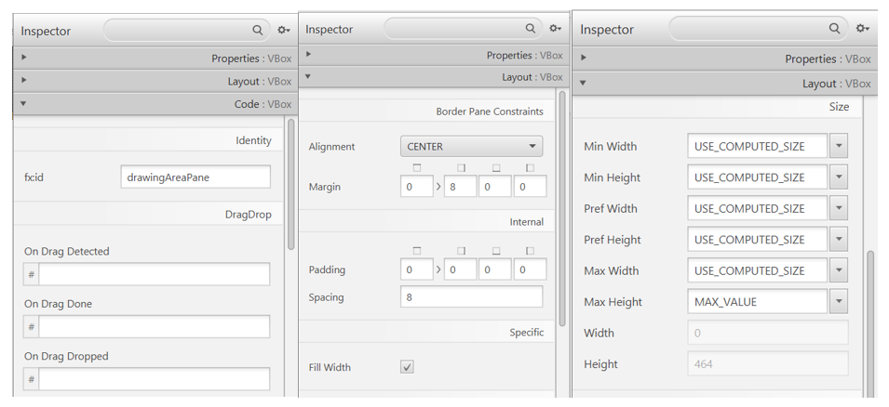

Figure : Configuring the VBox

Step 3. Adding the Pane

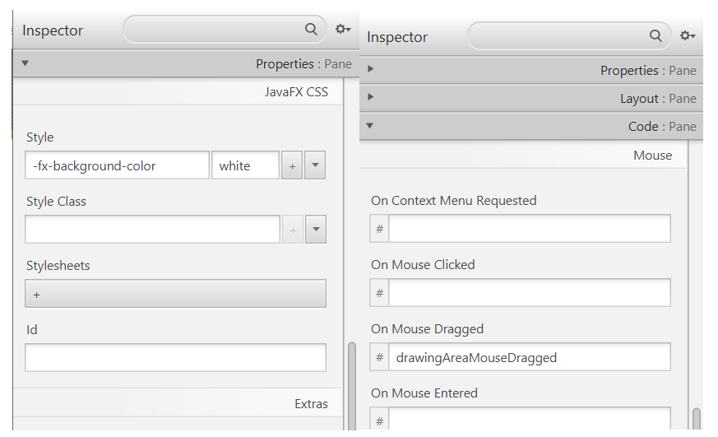

Figure : Configuring the Pane

Step 4. Adding the Button

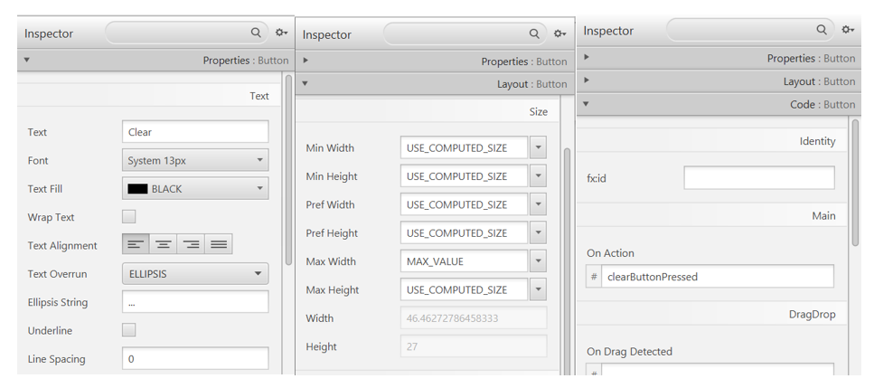

Figure : Configuring the Button

Preview:

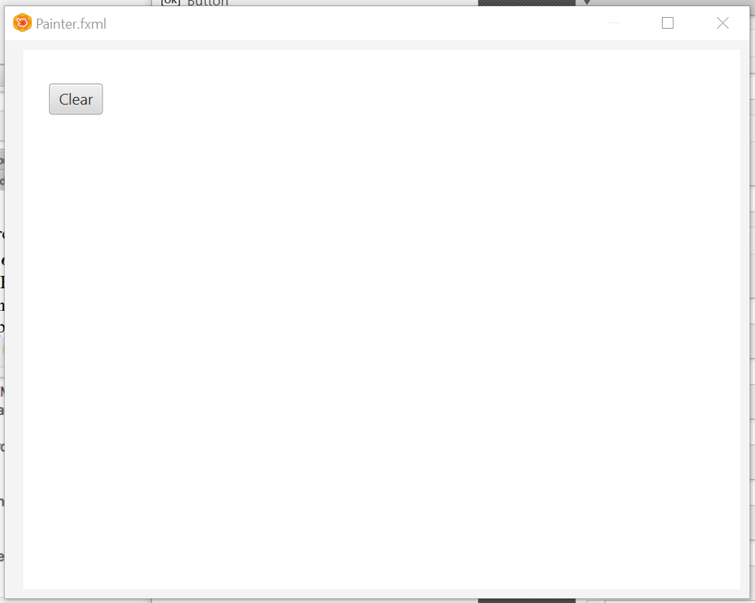

Figure : Preview in Window

Figure : Source code of Painter.fxml (2)

Figure : Source code of Painter.fxml (3)

4.2. Create the controller class

Figure : Source code of PainterController Class

## 4.3. Create the application

Figure : Painter source code

## 4.4. Practice exercise

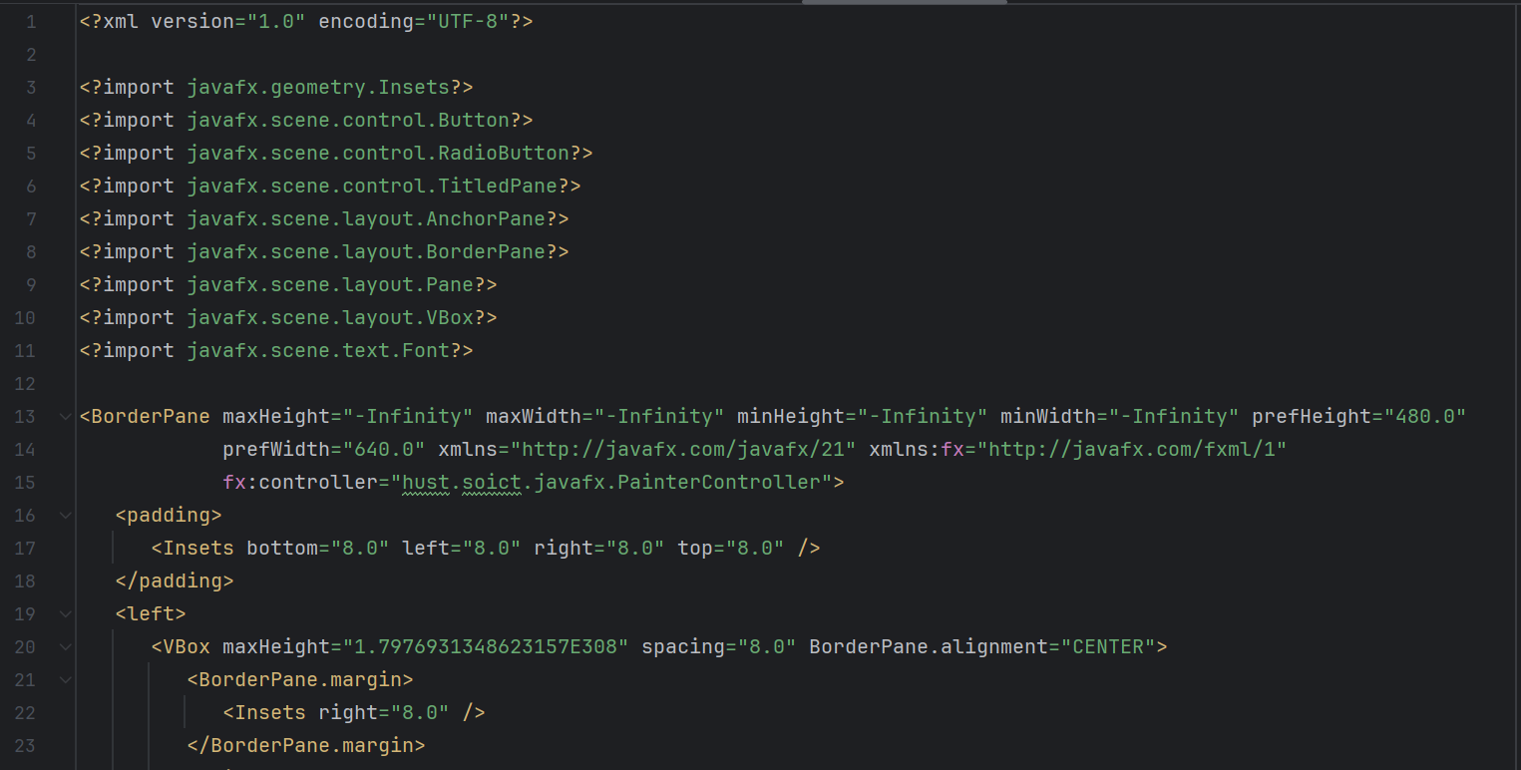

Figure : Source code of Painter.fxml update (1)

Figure : Source code of Painter.fxml update (2)

Figure : Source code of Painter.fxml update (3)

Figure : Painter with Eraser

# 5. Setting up the View Cart Screen with ScreenBuilder

Figure : Source code of Cart.fxml (1)

Figure : Source code of Cart.fxml (2)

Figure : Source code of Cart.fxml (3)

Figure : Source code of Cart.fxml (4)

Figure : Source code of Cart.fxml (5)

Figure : View Cart Screen

# 6. Integrating JavaFX into Swing application – The JFXPanel class

Figure : Source code for CartScreen(1)

Figure : Source code for CartScreen(2)

# 7. View the items in cart – JavaFX’s data-driven UI

Figure : Source code for CartScreenController (1)

Figure : Source code for CartScreenController (3)

# 8. Updating buttons based on selected item in TableView – ChangeListener

Figure : Modified initialize() method

Figure : Source code of updateButtonBar()

# 9. Deleting a media

Figure : Handle remove media

# 10. Filter items in cart – FilteredList

Figure : Creat corresponding attributes in the controller

Figure : Adding ChangListener for tfFilter in initialize()

Figure : Source code of showFilteredMedia()

# 11. Complete the Aims GUI application

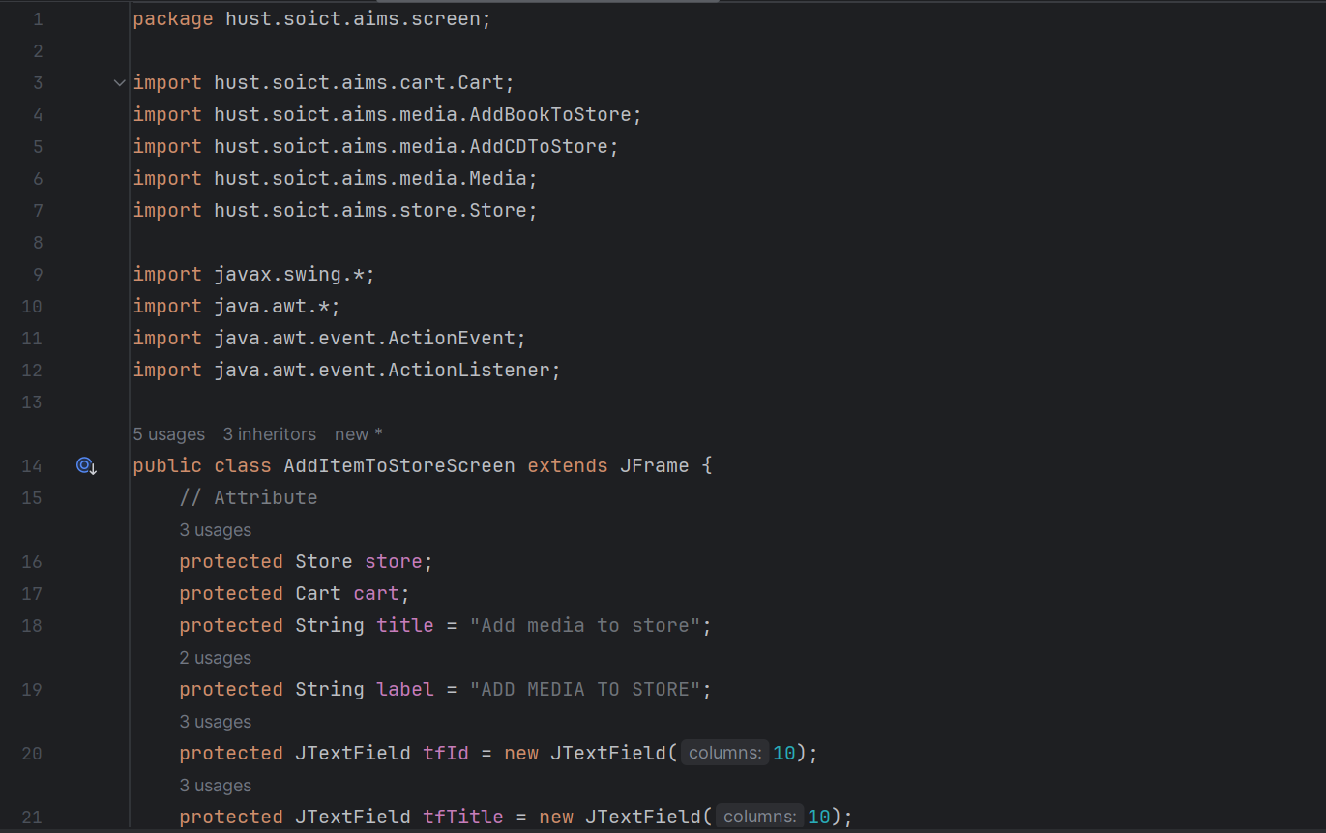

# 12. Use case Diagram

Figure : UseCase Diagram Customer

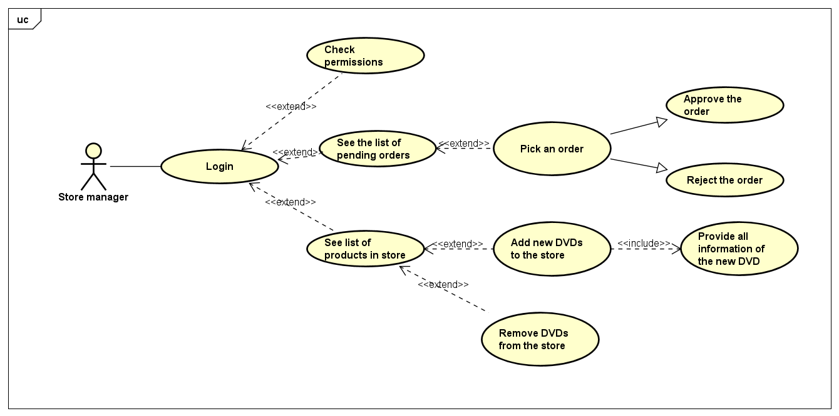

Figure : UseCase Diagram Store manager

# 13. Class Diagram

Figure : Class Diagram update